Chapter 6, Solution 25.

- For the capacitors in series,

Q₁ = Q₂ C₁v₁ = C₂v₂ 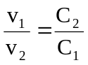
v_{s} = v₁ + v₂ = 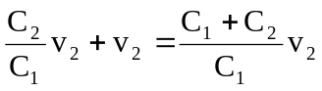 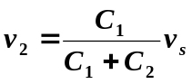

Similarly, 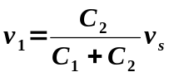

- For capacitors in parallel

v₁ = v₂ = 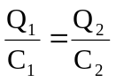
Q_{s} = Q₁ + Q₂ = 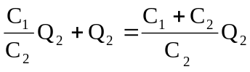
or
Q₂ = 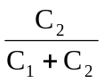
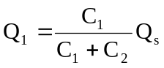

i =  